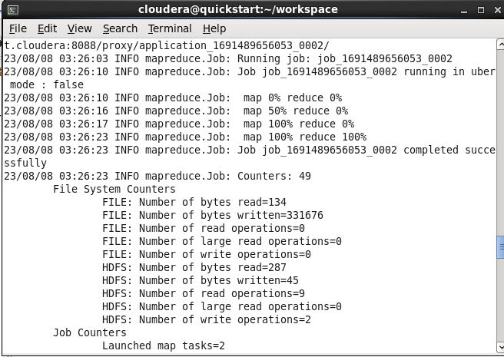

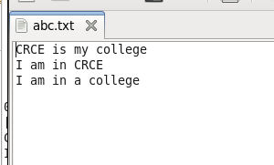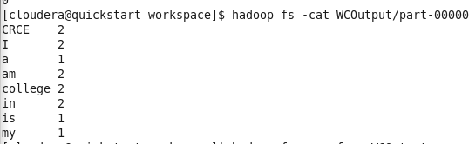

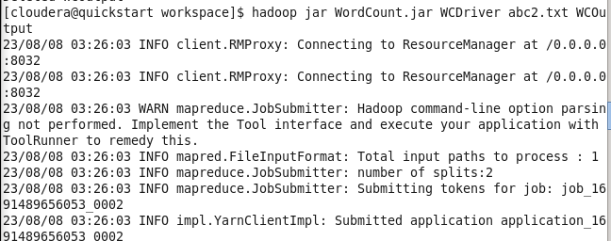

hadoop fs -put WCFile.txt WCFile.txt

hadoop jar WordCount.jar WCDriver WCFile.txt WCOutput hadoop fs -cat WCOutput/part-00000